2025 STFOA

FOOTBALL CREW ROSTER

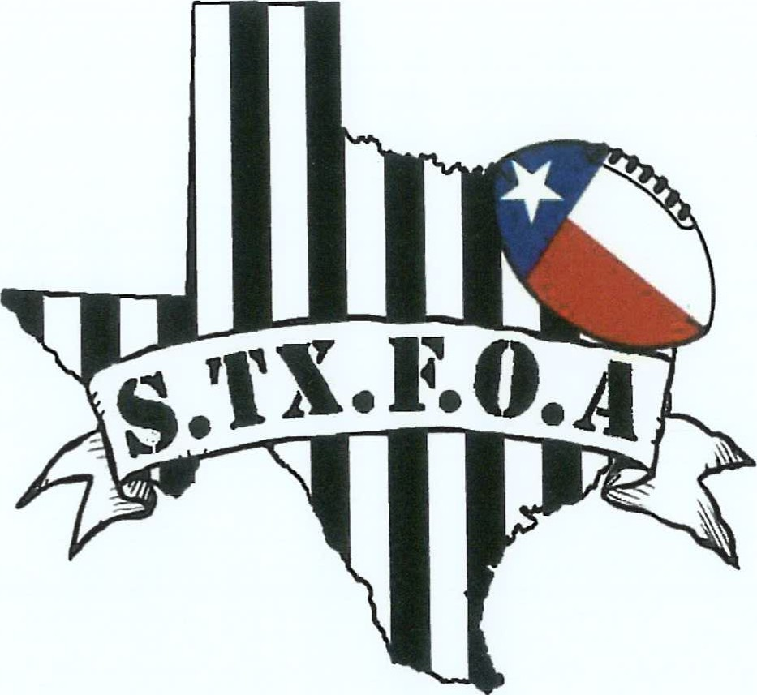

SOUTH TEXAS CHAPTER

P O BOX 4984

CORPUS CHRISTI, TX 78469

(361) 888-5900

2025 SOUTH TEXAS FOOTBALL OFFICIALS ASSOCIATION

BOARD OF DIRECTORS

Email: val_moreno [1030@yahoo.com](mailto:1030@yahoo.com)

Vice President: Oscar Benavides

Assigning Secretary: Jesse Perez

Email: weperz@gmail.com

Treasurer: Joel Hilliard

Recording Secretary: Howard Schauer

District 12 Director/IPP: Anthony Ford

President - TASO Football: Joel Hilliard Email: [Joel@stx.rr.com](mailto:Joel@stx.rr.com)

## DIVISION REPRESENTATIVES

Division 1 Representative: Pete Aguirre

Division 2 Representative: Harold Christianson

Division 3 Representative: Oscar Ortiz

Division 4 Representative: Mateo Requenez

Division 5 Representative: Maurice Robinson

STFOA Training Directors: Patrick Carter / Kyle Fuehrer

Email: carterp970@yahoo.com / fl fuehrer@gmail.com

STFOA Satellite Secretaries: Tony Solis / Jason Weischwill Email: tonysolisl 1 [14@yahoo.com](mailto:14@yahoo.com) [/jweischwill@hotmail.com](mailto:/jweischwill@hotmail.com)

2025

SOUTH TEXAS FOOTBALL OFFICIALS ASSOCIATION

### CREW LIST

Page 17 Ref: John Corona Ump: Horacio Lomas HL: Billy McLendon LJ: Michael Hernandez

BJ: Earl Kronk FJ: Oscar Benavides SJ: Howard Schauer

Page 18 Ref: Val Moreno Ump: John Ray HL: Rene Raymond LJ: Rick Ruiz

BJ: Tony Solis FJ: Clayton Dawson SJ: Esequiel Moreno

Page 19 Ref: Patrick Carter Ump: James Trankner Ill HL: Robert Janosek LJ: Jorge Lozano

BJ: Guy Espinoza FJ: Edward Manning SJ: Jonathan Rogers

Page 20 Ref: Robert Trevino Ump: David Herrera HL: John Valdez LJ: Jessie Perez

BJ: Sam Smith FJ: Joe English SJ: Malik Jones

Page 21 Ref: Luz Ramos Ump: Raul Ortiz HL: Pete Aguirre LJ: Oscar Ortiz

BJ: Cris Lucas FJ: Matthew Ortiz SJ: Christian Delgado

Page 22 Dicky Rodriguez Ump: Fred Garza HL: Fred Garza LJ: John Beltz

BJ: John Corkill FJ: Kalina Tostado SJ: Thomas Gutierrez

Page 23 Ref: Art Green Ump: Kevin Kieschnick HL: Mike Klotz LJ: John Temple BJ: Jeff Rosser FJ: Paul Startz SJ: Robert Hernandez

Page 24 Ref: Modesto Villanueva Ump: Robert Cantu HL: JR Castillo LJ: Rick Olivares BJ: Ernesto Morales FJ: Jimmy Alaniz SJ: Michael Lira

Page 25 Ref: Joseph Lopez Ump: Joey Cabrera HL: Christian Perez LJ: Mateo Requenez BJ: James Rodriguez FJ: Jason Perez SJ: Xavier Irving

Page 26 Ref: Robert White Ump: Larry Spears HL: Ben Amoles LJ: Tim Hanselka

BJ: Arnold Muniz FJ: John Trevino SJ: Javier Sanchez

Page 27 Ref: Rob Newton Ump: Mark Trammell HL: Craig Underbrink LJ: Marc Harrod BJ: Gary Underbrink FJ: Patrick Puebla SJ: P.J. Williams

Page 28 Ref: Harold Christiansen Ump: Eban Rolle HL: Benji Brewer LJ: Kevin Lewis

BJ: Ruben Hernandez FJ: Maurice Robinson SJ: Tyler Brewer

Page 29 Ref: Greg Brooks Ump: Juan Chapa HL: Roy Ferdin LJ: Robert Grajeda

BJ: Jesus Villarreal FJ: Ryan Buckner SJ: Hector Puebla

Page 30 Ref: Ramon Trevino Ump: Rudy Olmos HL: Jorge Camarillo LJ: Joshua Vasquez BJ: Adrian Garcia FJ: Tobias Trevino SJ: Larry Amaya Sr.

Page 31 Ref: Bebe Adamez Ump: Roland Salazar HL: Richard Cantu Jr. LJ: John Garcia BJ: Bernie Saenz FJ: Eloy Rodriguez SJ: JC Colmenero

Page 32 Ref: Darryl McDonald Ump: Xavier Hores HL: Serviano Flores LJ: Antonio Cuellar

BJ: Mark Beauford FJ: Maricela Rocha SJ: Francisco Rodriguez

Page 33 Ref: Jared Marks Ump: Gabriel Rivera HL: Rudy Olmos Il LJ: Albert Walker BJ: Joe Gonzales FJ: Raul Morales SJ: Tim Hamilton

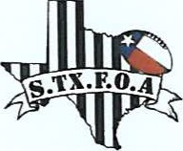

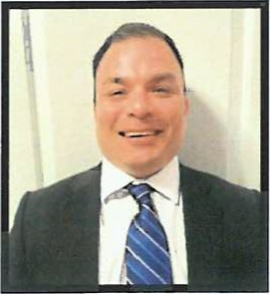

### JOHN CORONA

# DIVISION 1

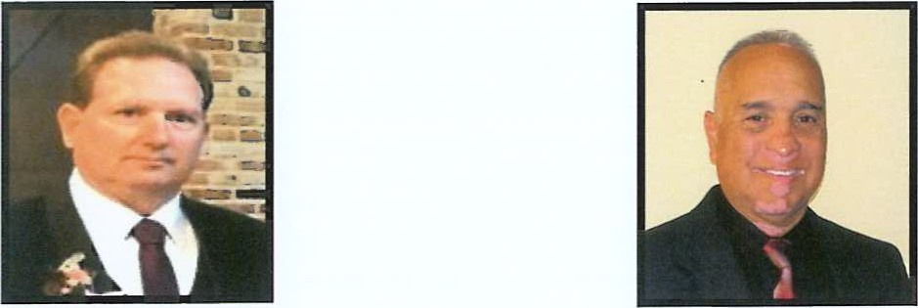

BILLY McLENDON OSCAR BENAVIDES

# DIVISION 1 DIVISION 1

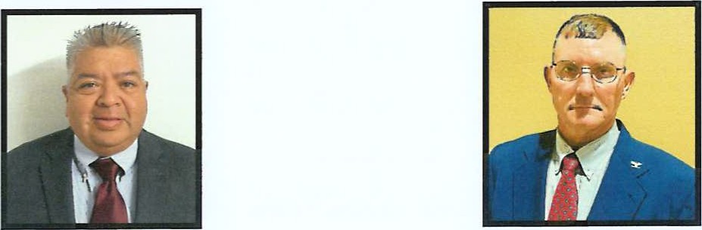

HORACIO LOMAS HOWARD SCHAUER

DIVISION 1 DIVISION 2

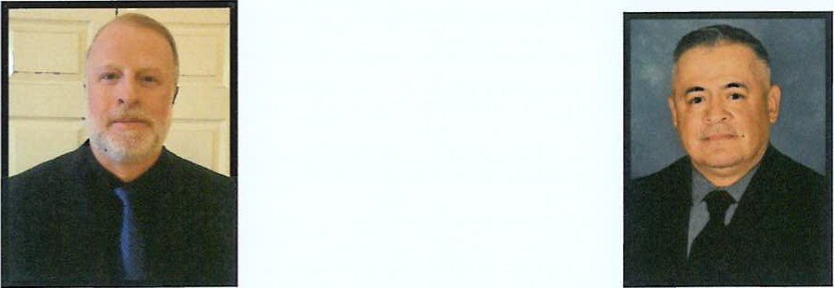

EARL KRONK MICHAEL HERNANDEZ

DIVISION 3 DIVISION 3

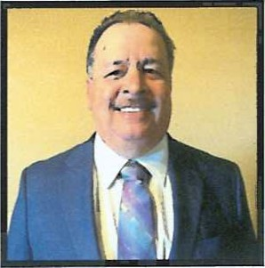

VAL MORENO

### DIVISION 1

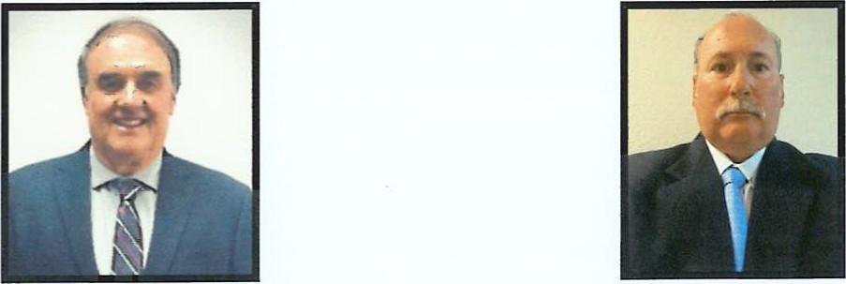

JOHN RAY RENE RAYMOND

DIVISION 1 DIVISION 1

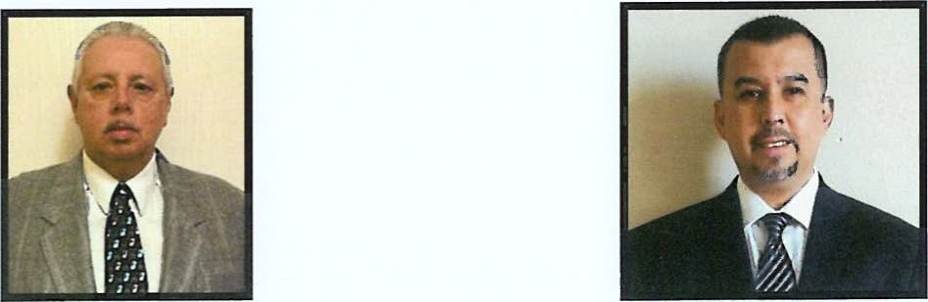

TONY SOLIS RICK RUIZ

DIVISION 1 DIVISION 1

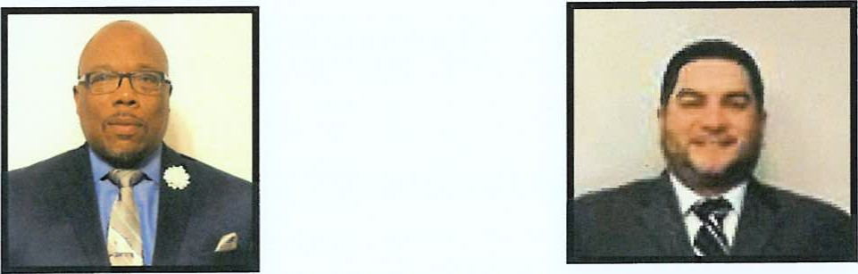

CLAYTON DAWSON ESEQUIEL MORENO

DIVISION 2 DIVISION 3

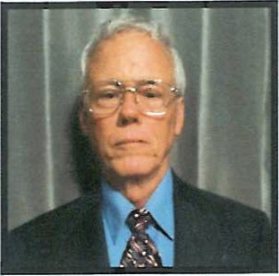

#### PATRICK CARTER DIVISION 1

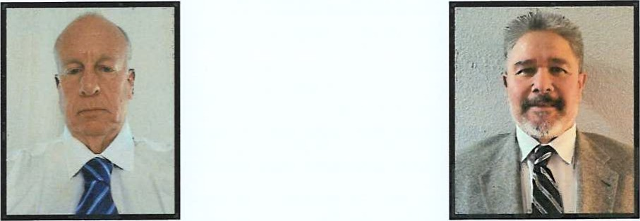

JONATHAN ROGERS GUY ESPINOSA

DIVISION 2 DIVISION 3

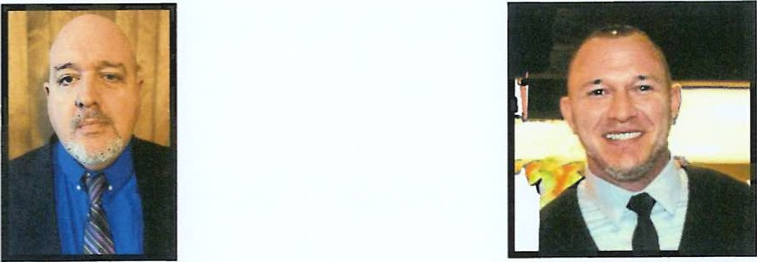

JAMES TRANKNER 111 ROBERT JANOSEK

DIVISION 3 DIVISION 4

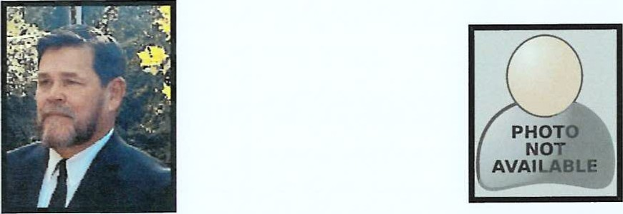

### EDWARD MANNING JORGE LOZANO

DIVISION 4 DIVISION 5

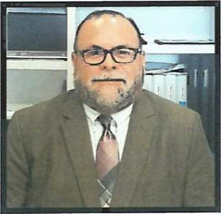

ROBERT TREVINO

### DIVISION 1

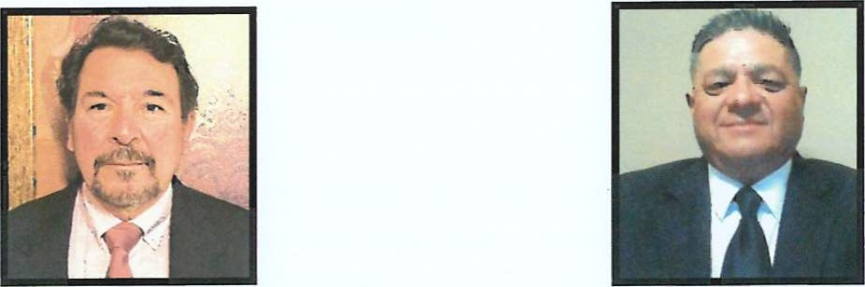

DAVID HERRERA JOHN VALDEZ

DIVISION 1 DIVISION 1

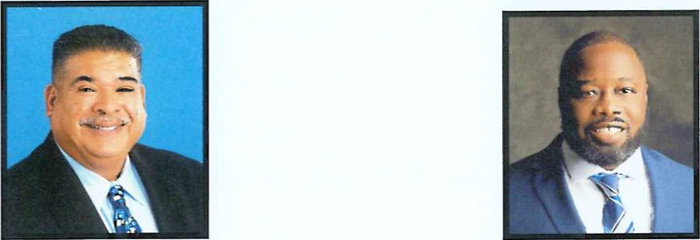

JESSIE PEREZ JOE ENGLISH

DIVISION 1 DIVISION 3

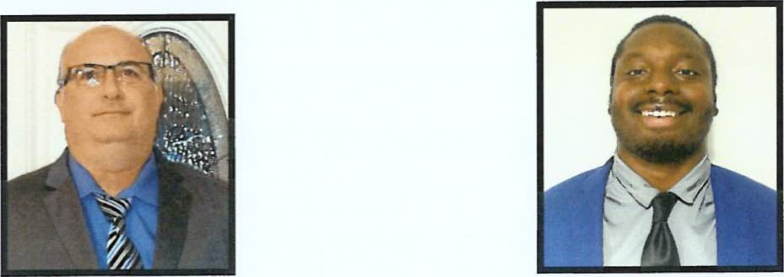

SAM SMITH MALIK JONES

DIVISION 3 DIVISION 4

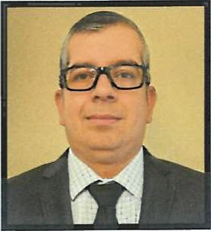

LUZ RAMOS

DIVISION 2

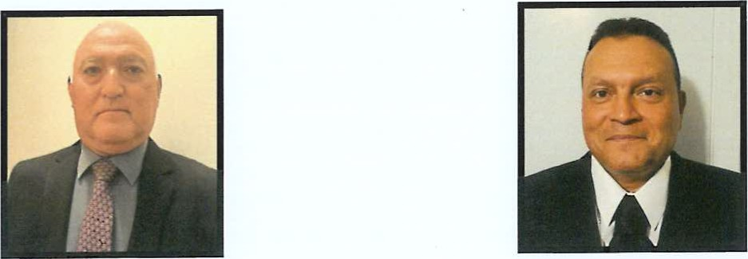

PETE AGUIRRE RAUL ORTIZ

DIVISION 1 DIVISION 1

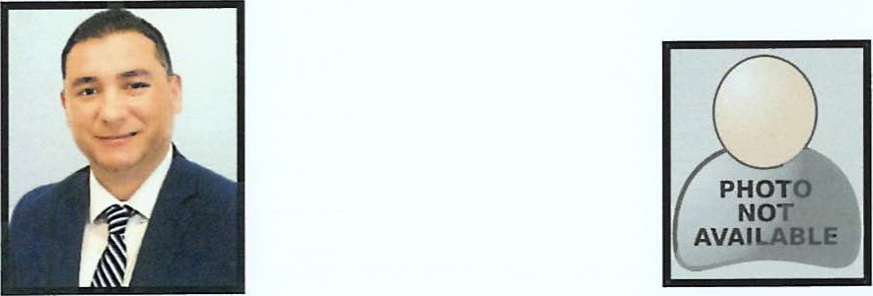

CRIS LUCAS OSCAR ORTIZ

DIVISION 2 DIVISION 3



### MAYHEW ORTIZ CHRISTIAN DELGADO

### DIVISION 5 DIVISION 5

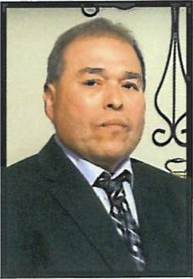

### DICKY RODRIGUEZ DIVISION 1

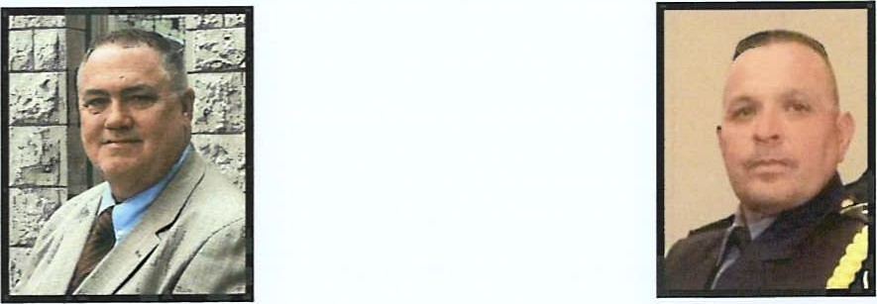

JOHN BELTZ THOMAS GUTIERREZ

DIVISION 1 DIVISION 2

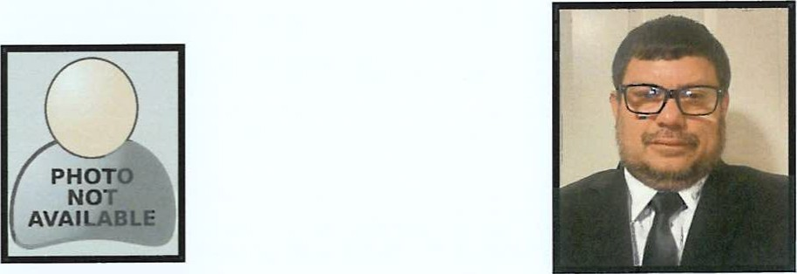

MARK DIERINGER FRED GARZA

DIVISION 3 DIVISION 3

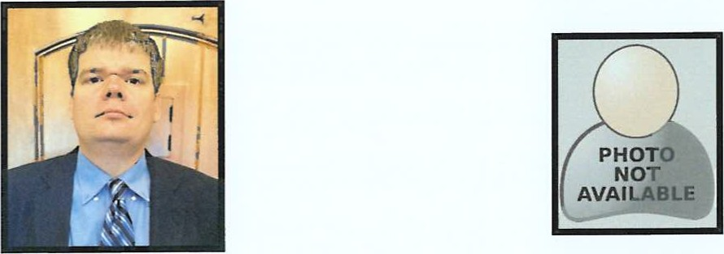

JOHN CORKILL KALINA TOSTADO

DIVISION 5 DIVISION 5

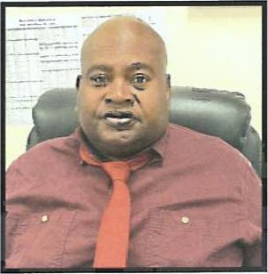

#### ART GREEN

#### DIVISION 3

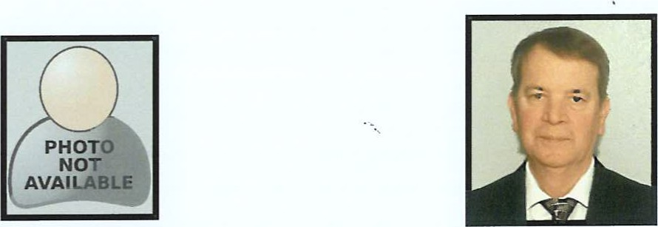

JOHN TEMPLE PAUL STARTZ

DIVISION 2 DIVISION 2

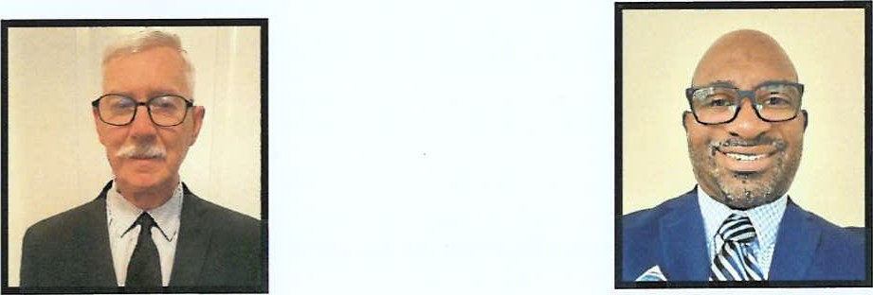

MIKE KLOTZ JEFF ROSSER

DIVISION 3 DIVISION 3

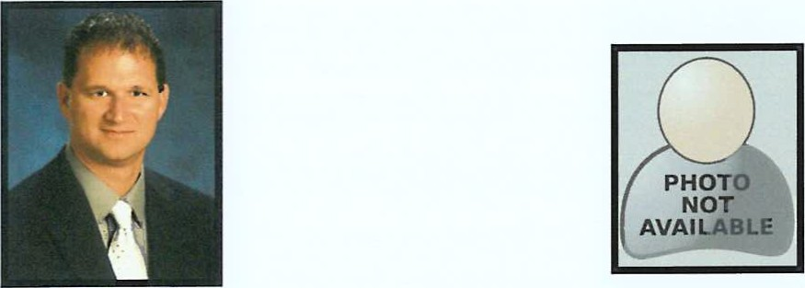

### KEVIN KIESCHNICK ROBERT HERNANDEZ

DIVISION 4 DIVISION 5

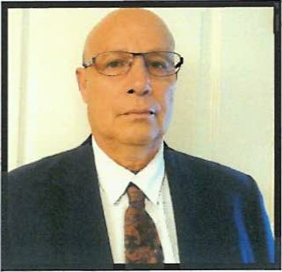

### MODESTO VILLANUEVA DIVISION 3

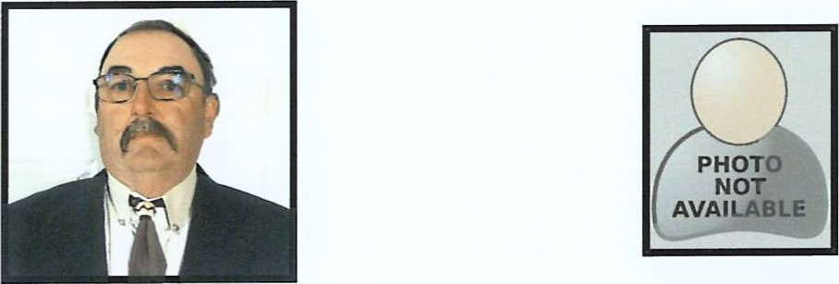

ROBERTO CANTU RICK OLIVARES

DIVISION 1 DIVISION 2

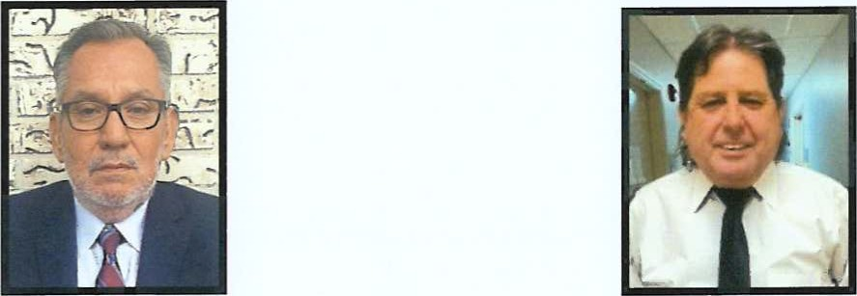

JIMMY ALANIZ ERNESTO MORALES

DIVISION 3 DIVISION 3

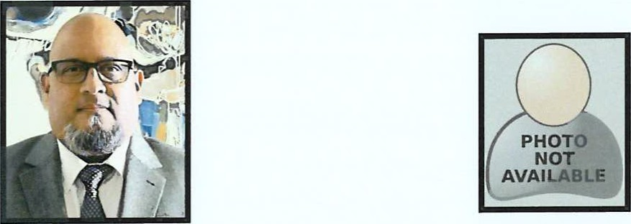

MICHEAL LIRA JR CASTILLO

DIVISION 3 DIVISION 4

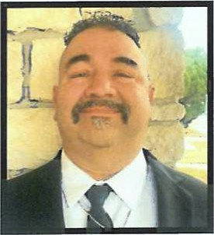

### JOSEPH LOPEZ DIVISION 1

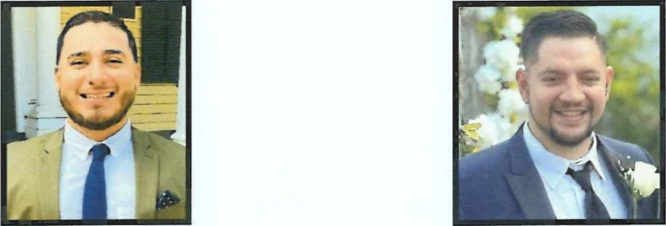

JAMES RODRIGUEZ JASON PEREZ

DIVISION 2 DIVISION 3

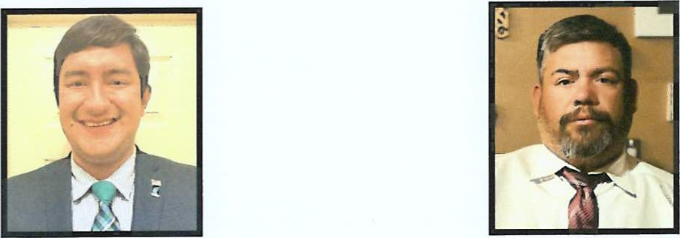

CHRISTIAN PEREZ JOEY CABRERA

DIVISION 3 DIVISION 3

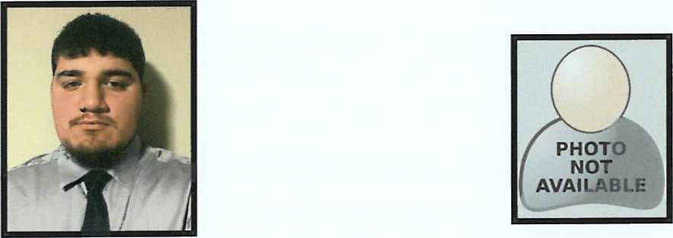

MATEO REQUENEZ XAVIER IRVING

DIVISION 4 DIVISION 5

### ROBERT WHITE DIVISION 1

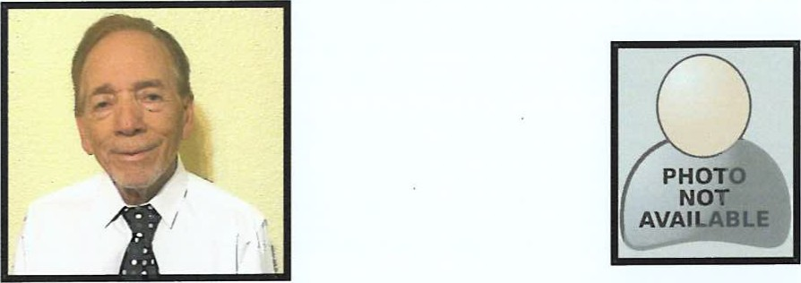

ARNOLD MUNIZ BEN AMOLES

DIVISION 1 DIVISION 1



JAVIER SANCHEZ LARRY SPEARS

DIVISION 2 DIVISION 4

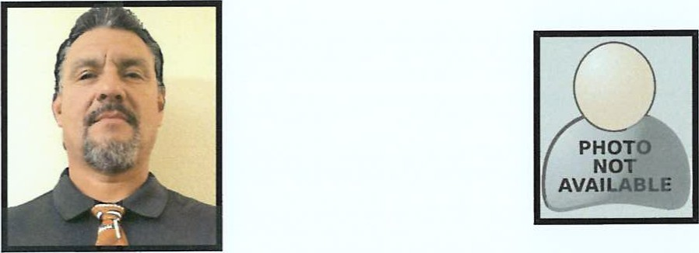

JOHN TREVINO TIM HANSELKA

DIVISION 4 DIVISION 5

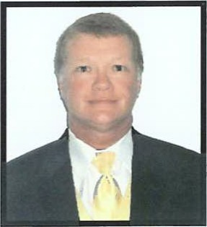

### ROB NEWTON

### DIVISION 1

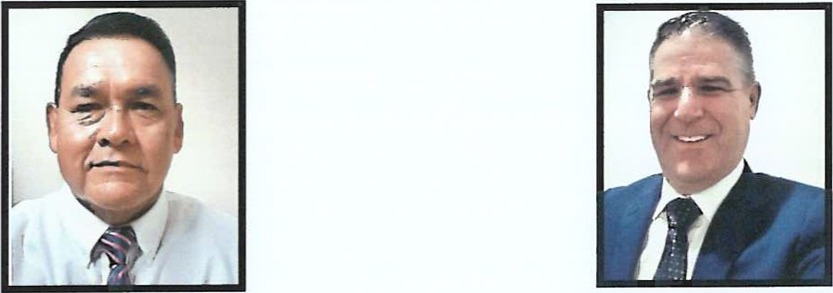

MARK TREMMELL MARC HARROD

DIVISION 1 DIVISION 1

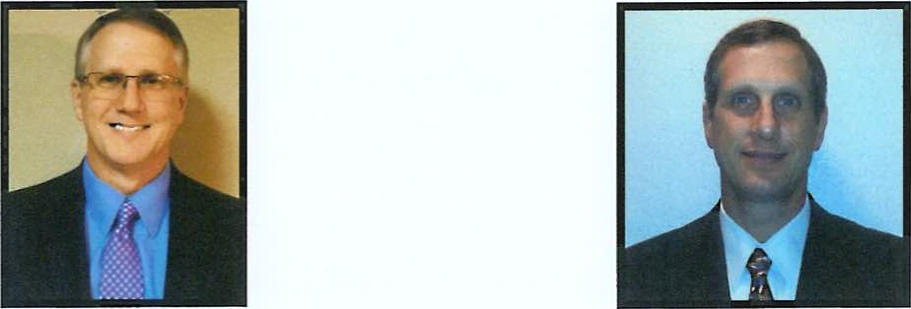

CRAIG UNDERBRINK GARY UNDERBRINK

DIVISION 1 DIVISION 1

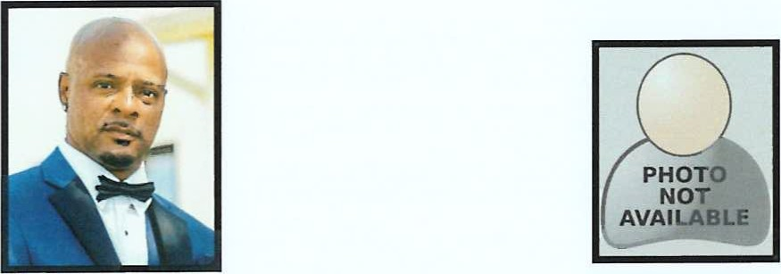

P.J. WILLIAMS PATRICK PUEBLA

DIVISION 2 DIVISION 2

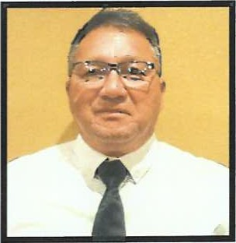

### HAROLD CHRISTIANSON DIVISION 2

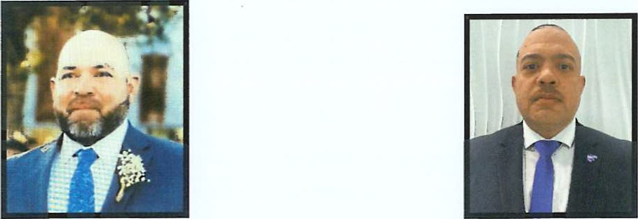

RUBEN HERNANDEZ EBAN ROLLE

DIVISION 1 DIVISION 3

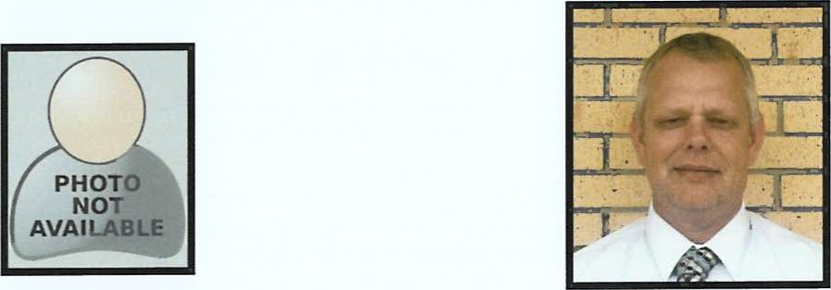

KEVIN LEWIS BENJI BREWER

DIVISION 4 DIVISION 4

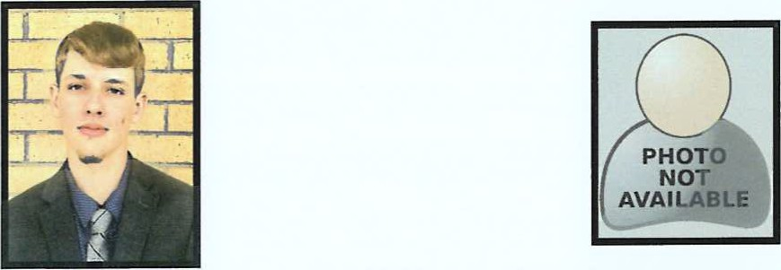

### NLER BREWER MAURICE ROBINSON

DIVISION 4 DIVISION 5

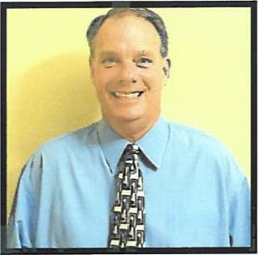

### GREG BROOKS DIVISION 1

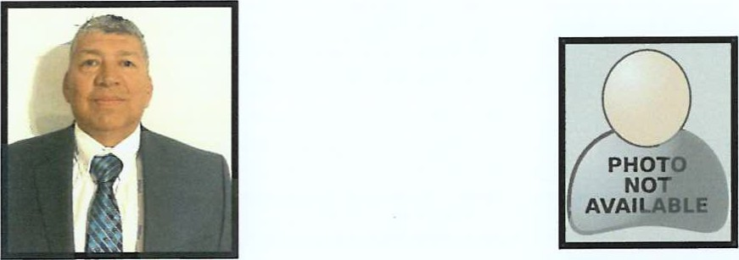

ROY FERDIN ROBERT GRAJEDA

DIVISION 1 DIVISION 3

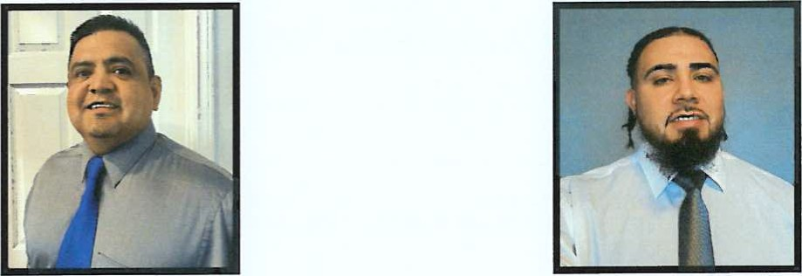

JUAN CHAPA JESUS VILLARREAL

DIVISION 3 DIVISION 4

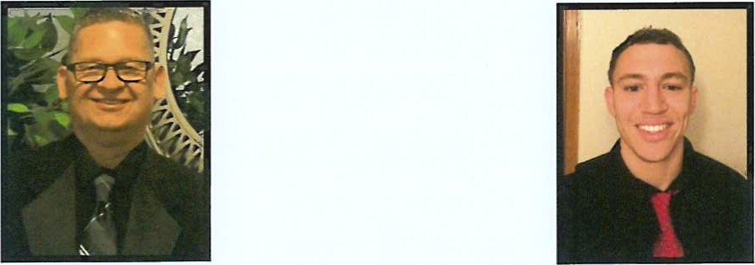

HECTOR PUEBLA RYAN BUCKNER

DIVISION 4 DIVISION 4

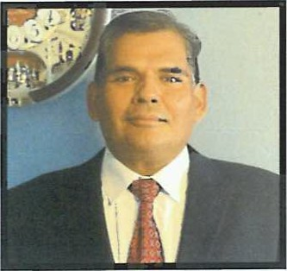

### RAMON TREVINO DIVISION 2

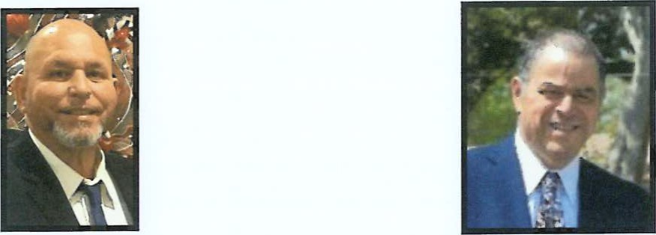

RUDY OLMOS LARRY AMAYA SR.

DIVISION 1 DIVISION 4



TOBIAS TREVINO JOSHUA VASQUEZ

DIVISION 4 DIVISION 4

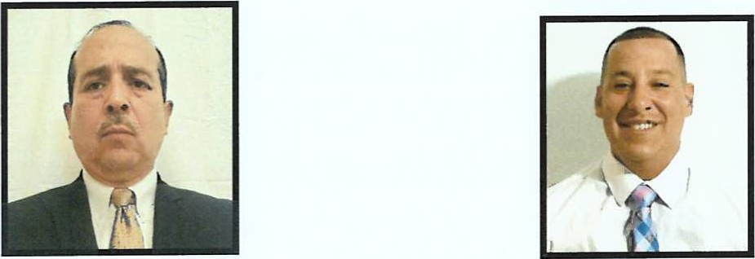

### JORGE CAMARILLO ADRIAN GARCIA

DIVISION 5 DIVISION 5

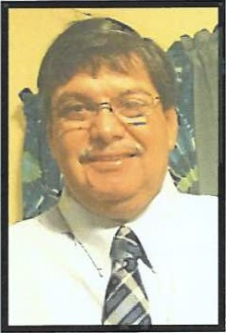

### BEBE ADAMEZ DIVISION 3

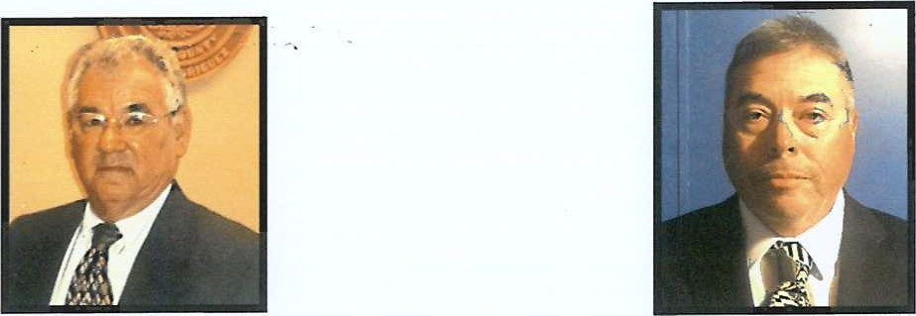

ELOY RODRIGUEZ ROLAND SALAZAR

DIVISION 1 DIVISION 2

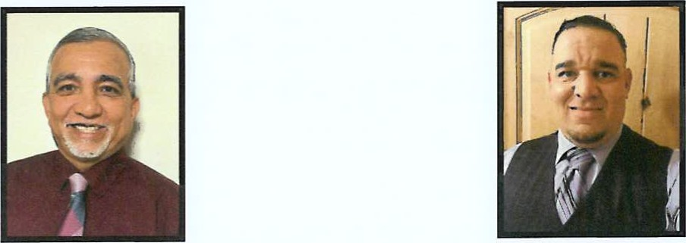

BERNIE SAENZ JOHN GARCIA

DIVISION 3 DIVISION 4

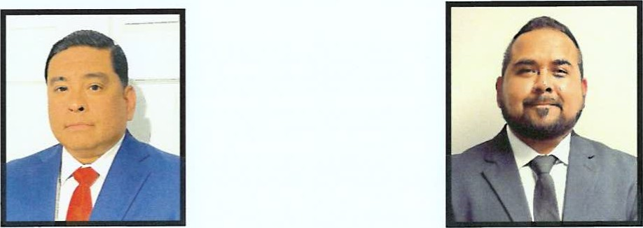

RICHARD CANTU JR. JC COLMENERO

4 4



### DARRYL McDONALD DIVISION 1

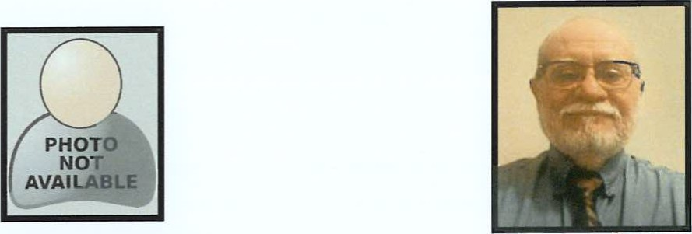

MARK BEAUFORD SERVIANO FLORES

DIVISION 1 DIVISION 2

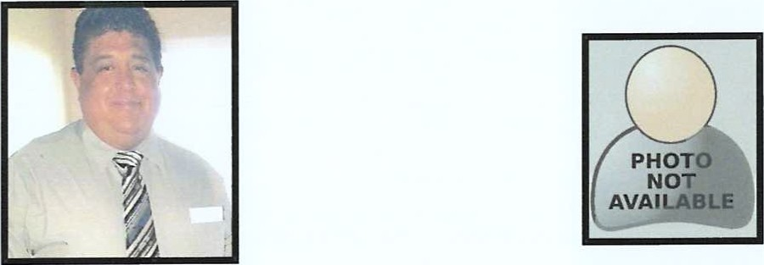

ANTONIO CUELLAR XAVIER FLORES

DIVISION 3 DIVISION 4

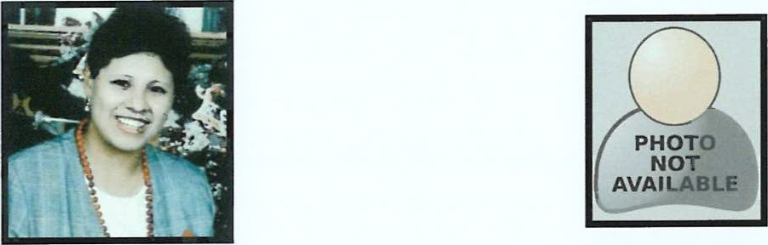

MARICELA ROCHA FRANCISCO RODRIGUEZ

4

### JARED MARKS DIVISION 1

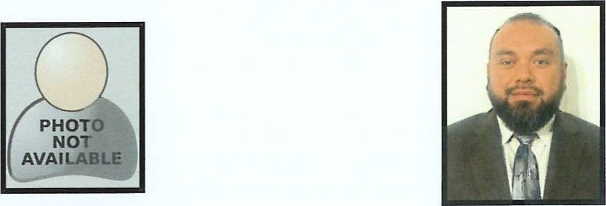

RUDY OLMOS 11 GABRIEL RIVERA

DIVISION 2 DIVISION 3

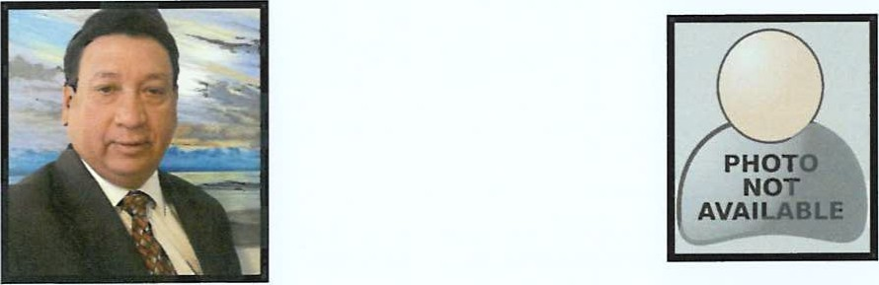

RAUL MORALES JOE GONZALES

DIVISION 3 DIVISION 5

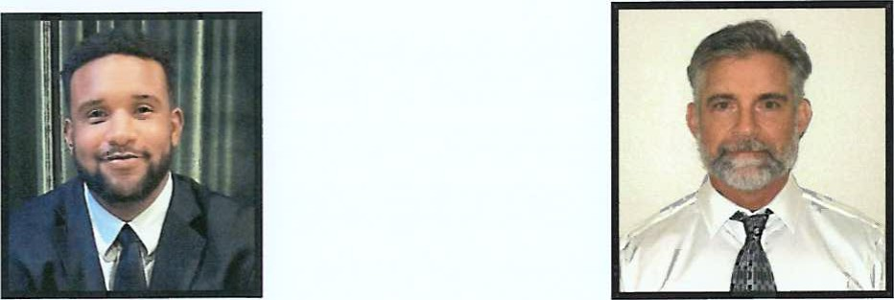

ALBERT WALKER TIM HAMILTON

DIVISION 5 DIVISION 5

